Line Balancing
Line balancing in a layout means balancing the production line or an assembly line. The main objective of line balancing is to distribute tasks evenly over the workstation so that idle time of man and machines is minimized.
Suppose, there are three machines (work stations) A, B and C which can process 25, 50 and 100 pieces per hour respectively and the pieces flow from A to B to C (precedence constraint). Since, A has minimum capacity, i.e. of processing 25 pieces per hour, work station or machine B will remain idle for 50% of its time and machine C will also remain idle for 50% of its time. Such a layout will be unbalanced one and the production time needs to be balanced.
The actual production in the line will be decided on the basis of the machine with the maximum production capacity. The production capacity of the other machines in the line will be adjusted through the increase in the number of machines. In this case, machine C produces 100 units per hour, hence 100 units will be manufactured per hour with the help of two machines B and from machine A. Thus, the line balancing for the production 100 units per hour will be done by arranging four machines of type A, two machines of type B with one machine of type C. Thus the idle capacity will be totally eliminated. The arrangement is as shown in figure:
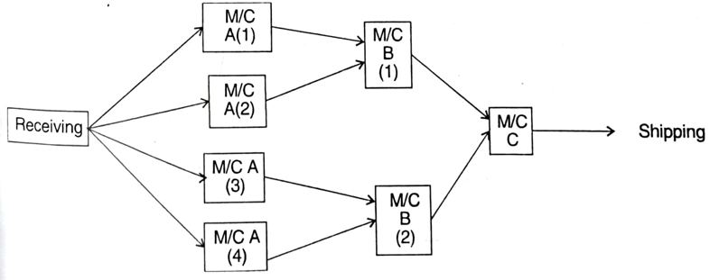

Two important concepts in line balancing are the separation of the total work content into minimum rational work elements and the precedence constraints that must be satisfied by these elements.
Minimum Rational Work Elements - A minimum rational work element is a small amount of work that has a specific limited objective, such as adding a component to the base part, joining two components, or performing some other small portion of the total work content. A minimum rational work element cannot be subdivided any further without loss of practicality. For example, drilling a through-hole in a piece of sheet metal or fastening two machined components together with a bolt or screw would be defined as minimum rational work elements. It makes no sense to divide these tasks into smaller elements of work.
Precedence Constraints - In addition to the variation in element times that make it difficult to obtain equal service times for all stations, there are restrictions on the order in which the work elements can be performed. Some elements must be done before others. For example, to create a threaded hole, the hole must be drilled before it can be tapped.
Precedence constraints can be presented graphically in the form of a precedence diagram, which is a network diagram that indicates the sequence in which the work elements must be performed. Work elements are symbolized by nodes, and the precedence requirements are indicated by arrows connecting the nodes. The sequence proceeds from left to right.
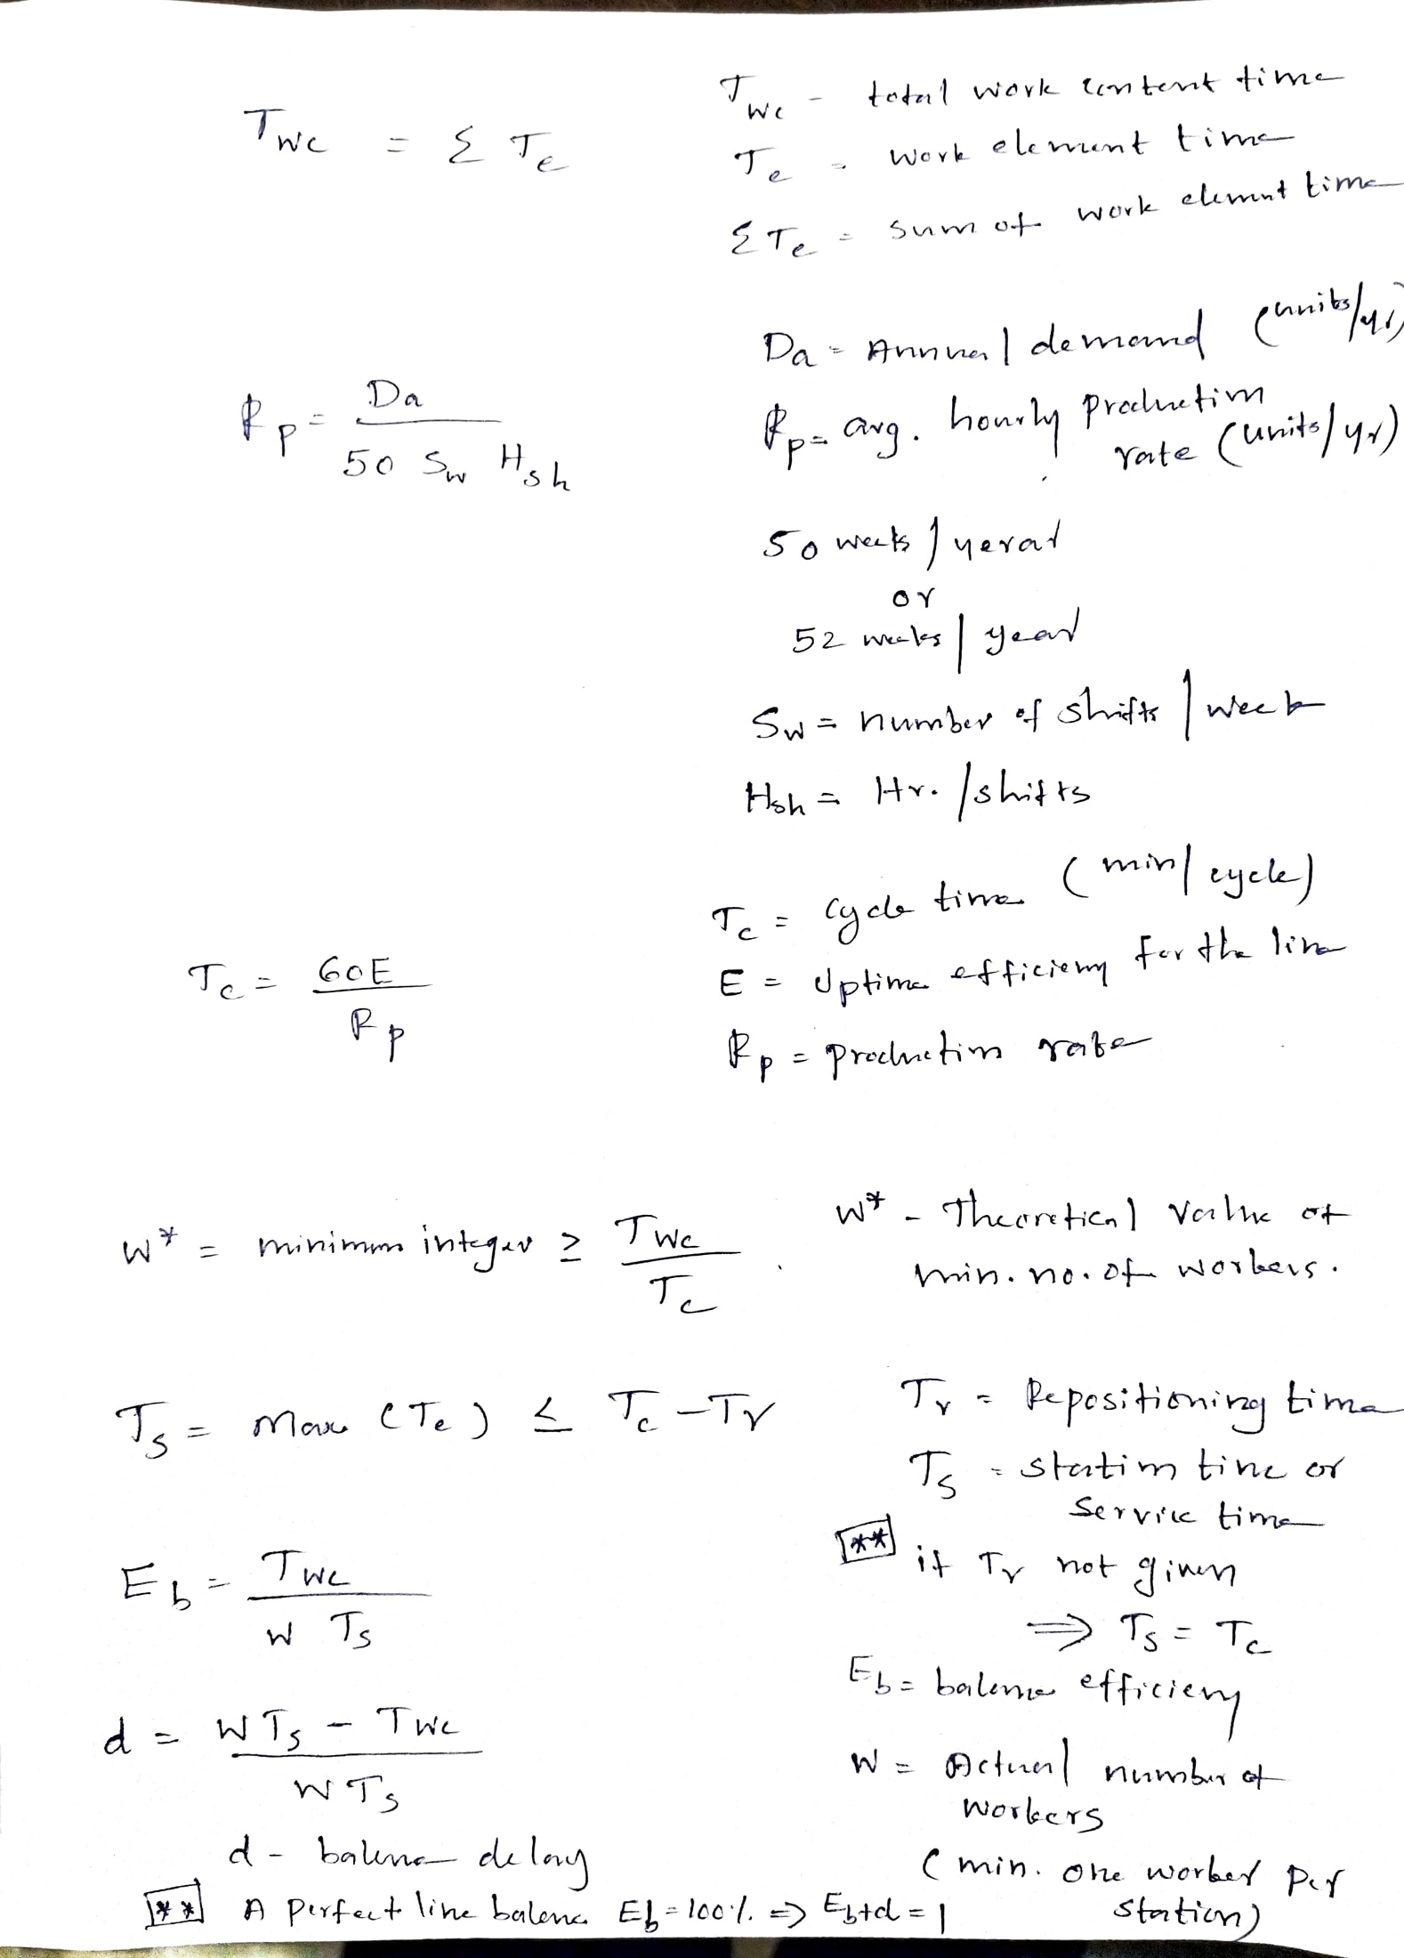
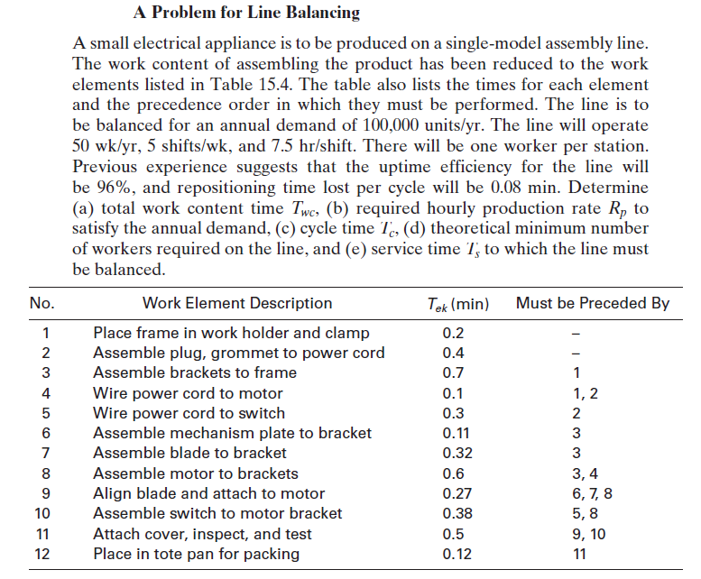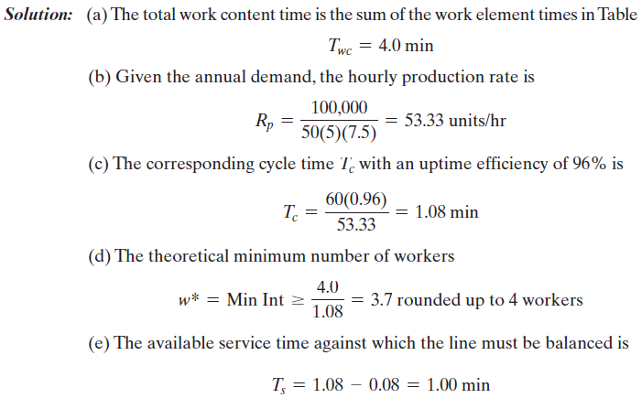

Line balancing algorithms
The objective in line balancing is to distribute the total workload on the assembly line as evenly as possible among the workers. several algorithms to solve the line balancing problem.
(1) largest candidate rule
(2) Kilbridge and Wester method
(3) ranked positional weights method

Largest Candidate Rule

Step – 1
Draw the Precedence diagram
Step - 2
work elements are arranged in descending order according to their Te (work element time) values.
Step -3
Assign elements to the first workstation by starting at the top of the list and selecting the first element that satisfies precedence requirements and does not cause the total sum of Te at that station to exceed the allowable Ts (station time).
When an element is selected for assignment to the station, start back at the top of the list (descending order data in step - 1 and Precedence diagram) for subsequent assignments. when no more elements can be assigned without exceeding Ts, then proceed to the next station
Step-4
Repeat the steps 1 and 2 for as many additional stations as necessary until all elements have been assigned.

Problem
A new small electrical appliance is to be assembled on a production flow line. The total job of assembling the product has been divided into minimum rational work elements. The industrial engineering department has developed time standards based on previous similar jobs. This information is given in the table below. In the right-hand column are the immediate predecessors for each element as determined by precedence requirements. Assuming a cycle time of 1.0 min, find out the balance delay. Solve above the problems using Largest Candidate Rule
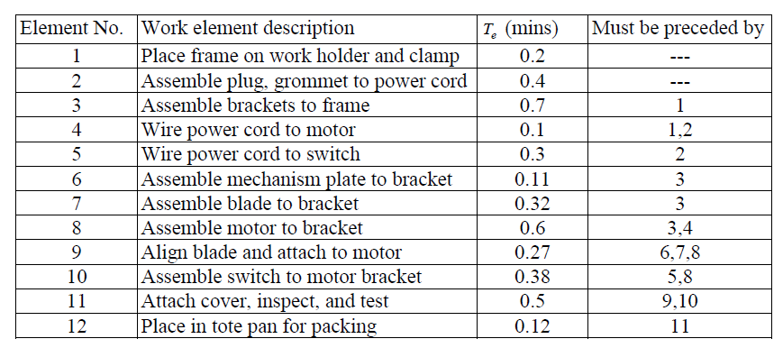
Solution
Step – 1
Precedence diagram for the above problem. Nodes represent work elements, and arrows indicate the sequence in which the elements must be done. Element times are shown above each node.
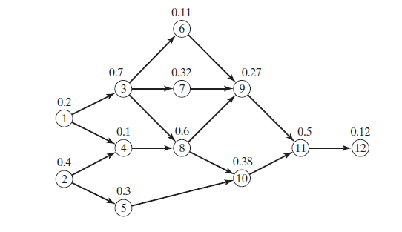
Step -2
Work Elements Arranged According to Te Value for the Largest Candidate Rule
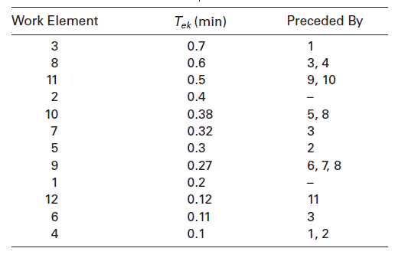
Step – 3
Work Elements Assigned to Stations According to the Largest Candidate Rule
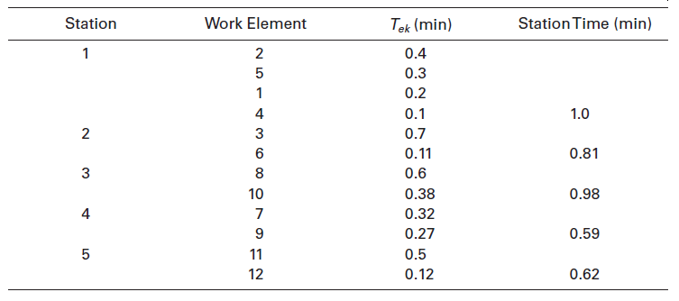
Based on the assignment the work flow is as given below
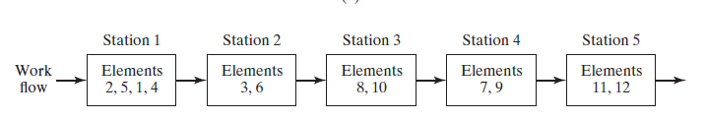

$$Balance delay d= \frac{wT_{c}-T_{wc}}{wT_{c}}=\frac{(5*1)-4}{5*1}=0.2=20\%$$

